MVC4

# PAGing

Add more a package

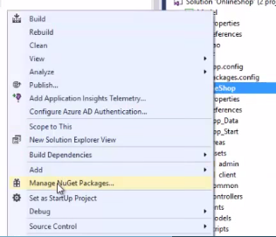

Search Pagelist to install

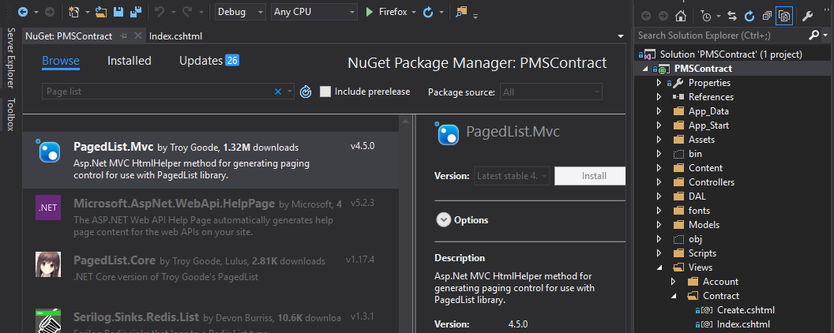

# using the layout temlate

Create an Assets folder

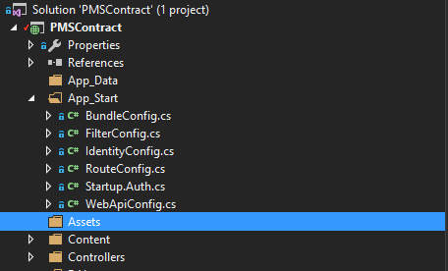

Copy source AdminLTE2 into Assets folder

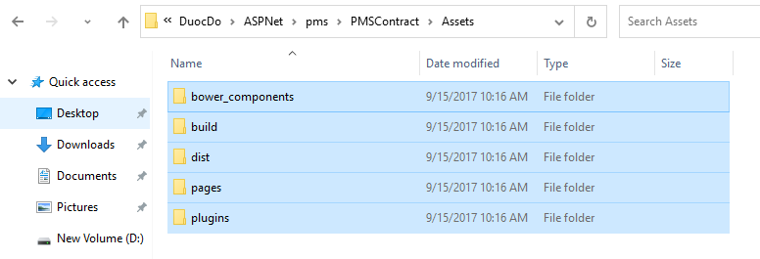

Create a _LayoutAdminLTE.cshtml on Views folder

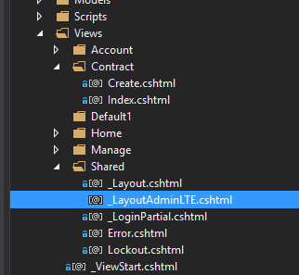

And then copy all source html into _LayhoutAdminLTE.cshtml and change something about links

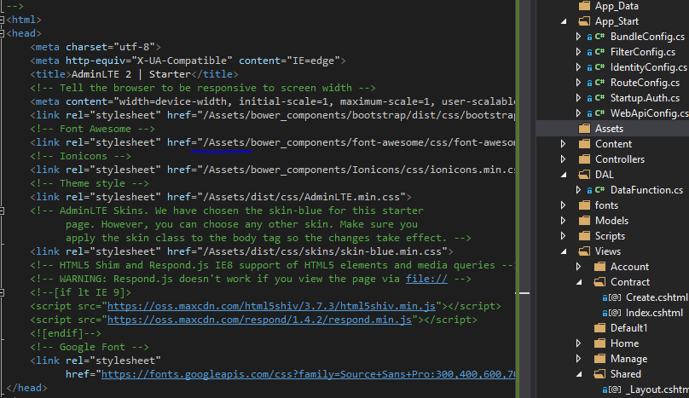

@RenderBody() // On master page

@RenderSection(“Varible_Name”,True or False) // On master page.

@section Varible_Name { HTML code in here …} // On children page, can put it anywhere.

# NOTES

Namespace chính là đường link của Model or Controller

# razor

<a href=”@Url.Action(“tenfile”,”TenFolder or Controller name”) title=”read our blog”>Read our blog</a> // apply for main menu

or <li> @Html.ActionLink(“Content text”,”tenfile”,”Folder link or Controller name”,”a route data object with default Null”, new { attribute ex: title=”Click here”})

@{ Layout-“_Layout”;}

@RenderBody()  
@RenderSection()  
@select any_name{

}

@select header{}

**PASS DATA FROM THE CONTROLLER TO THE VIEW (CONTROLLER - VIEW)**From file in Controller:  


From a file in View  


**Render data with strongly typed views (Model – (Controller and Views))  
+ on Model file  
  
+ on Controller file**

**CÁCH EXPORT DỮ LIỆU TỪ BÊN MODEL NHANH VÀO CONTROLLER FILE NHƯ HÌNH BÊN DƯỚI**



**hoặc gõ như hình sau**



**+ on Views file**



**REUSE VIEW MARKUP WITH PARTIAL VIEWS**

**+ Create a file on share folder with partial view property   
**

**named _Post.cshtml  
**

**Put the code on _Post.cshtml is @Html.Partial (“namefile”)  
**

**Finally, open a need file to use it and call @Html.Partial(“namefile”);**



# route

[Route(“path link”)] ex: [Rout(“”)], [Route(“Blog”)], [Route(“{year:min(2000)}/{month:range(1,12)/{key}}”]

# PAGing

Add more a package

# PAGing

Add more a package

# PAGing

sfssdfdsfsfssdssf

# PAGing

Add more a package